JULY/AUGUST NEWSLETTER

What a very busy June/July the club has had, the ODE ran well although a little wet at times! Well done to those who organised and helped out, these events would not run without your help. FVRC had good results in all the Area events (ODE, Dressage and Show jumping) see reports below.
The Annual show is fast approaching (27th August) there are classes for all so please take a look at the schedule on Horsedates and tell your friends! We have great sponsors for the classes too.
A DATE FOR YOUR DIARY FVRC members Bowling on the 22nd September, a chance to meet and chat to other members and committee members! And It’s FREE, Please let Rosie know if you are able to join us rosemary.stevens632@btinternet.com

Future Events
27th August FVRC Annual Show @ Westerfield – Affiliated & unaffiliated show jumping & Showing classes
October/November Long Distance Ride in Tunstall Forest TBC
22nd September FVRC Members Bowling Evening
Holkham Beach Ride TBC
Training Dates
These are open to members and non-members
Jonathan Allinson pole work Tammy Ruffles Flat work
25th August flat
29th September pole 15th September flat
20th October pole 13 October flat
Please contact Krystina Fish on 07525 020417 or Krystina3@fsmail.net if you would like to be involved in training.

One Day Event Sunday 24th June Gt. Witchingham
This year due to the strangles outbreak at Poplar Park we had to change venues and luckily David Sayer at Gt Witchingham was happy for us to hold it there, at first it was difficult to get helpers as most of our usual people said it was too far to travel. But on the day we had plenty of willing helpers we were so grateful to everyone who gave us their time.
The morning of the event the weather was horrid it had rained most of the night and still didn’t let up in the morning, good job James and Laura picked me up in there 4x4 as I don’t think I would have made it. It did ease a bit during the morning but then returned with thunder and hail and we then had a river running through the marquee, we did think at this stage the steward may stop the event, but no we carried on and actually as the day went on the weather did improve and the sun came out. The photographer did have a bad day, he was only there for a short time as the rain and thunder damaged his camera so he gave up and went.
We had good entries overall. We had a junior team of Isabella Stagg, Shirley Stagg, Joanne Parr and Isobel Sykes, and a Novice team of Jenny James, Caroline Steward, Amy Curl and Julia Sheppard. Jenny James rode in the Intermediate as an individual, these were all qualifiers. Nick Peek did also ride but not as a qualifier. Unfortunately 3 of the juniors did not ride in the end but Isabella did really well and came 1st and has qualified for the Championships at Aston le walls on the 3rd August, so we wish her well.
The Novice team did really well also coming 2nd, but unfortunately they did not qualify as you needed 13 teams to run for two teams to go through to the Championships, but there is always next year.
It was a challenging course but think most people enjoyed the day. Thanks to everyone who helped and made the day possible.
Report from Barbara Team Manager

Area 14 Dressage Results for FVRC
We only had one Novice team consisting of James Smith riding Joseph, Caroline Steward riding Supercatch, Julia Sheppard riding Hot Prospect and Krystina Fish riding Leudo all doing Prelim 14. Again the morning was wet, what is it with these qualifiers this year and rain but the team were in good spirits despite the weather. They all did good tests, Caroline with 161 came 2nd, James 149 came 11th, Julia 149 came 13th and Krystina came 5th, the team overall came 2nd but unfortunately did not qualify for the Championships.
Anne Corke riding Chuck did the Riding Test but it was not a good day for them and only managed to come 17th but it was raining very hard at the time and could not have helped. James riding Joseph did N27 and came 1st and we think qualified, Caroline riding Supercatch came 6th.
It was a good day and thank you to Deben RC for organising it.
Report from Barbara Team Manager

Area 14 Show Jumping and Style Jumping Geldeston Sunday 22nd July
The weather was great and the team ready to go. We had Julia Sheppard doing the Style Jumping riding Abby. First time she has done this so we did not know what to expect as you are supposed to jump without a martingale or you lose points not an easy thing to do with Abby, but that did not seem to be a problem, she went really well and finished up coming 6th out of about 22 riders.
We also had an Intermediate team with Rosie Stevens riding Gracie, Amy Curl riding Rough Diamond, Nicola Peek riding Lordships Dependancy and Julia riding Hot Prospect. First round, Rosie went clear and the others unfortunately had faults so we finished the first round with 8 points. Second round Rosie and Gracie had another clear round but as the others had faults we finished with 16 faults so we knew we had not qualified, but we did come 4th so well done team. Rosie had to do a jump off for an individual placing but unfortunately she rolled a pole and finished up coming 2nd.
It was a good day and well done to the team.

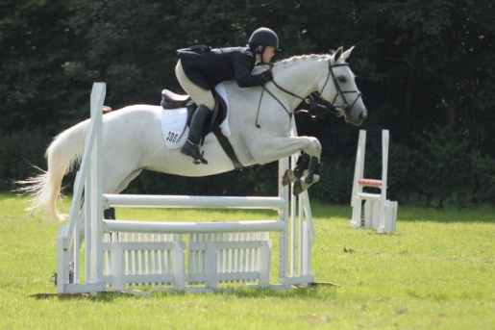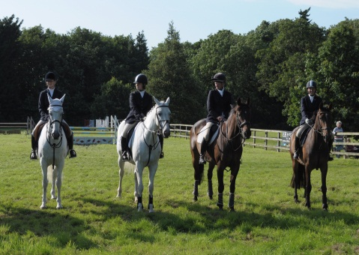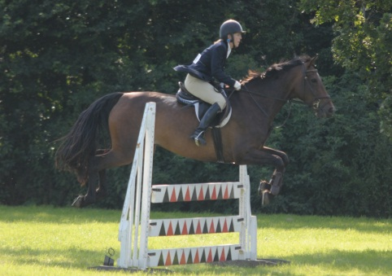
Report from Barbara Team Manager
Photos from Gordon Crane

BRC Horse Trial Championships
Isabella Stagg competed at BRC Horse Trial Championships at Aston le walls, she had a good dressage test and double clear jumping, just had time faults on the XC. Well done Isabella.

How has FVRC helped you …? Gordon Crane
I only joined FVRC quite recently but have been involved with the club for a while. 6 years ago I met Rosie Stevens who introduced me to the world of Horses, I travelled around to various horse shows with her and helped her as much as I could but, not knowing much about horses, I couldn’t help much but did my best. I found she did not have many photographs of herself and Gracie so I decided to purchase a camera and take some, she now has loads!! Rosie joined FVRC and I started to go to team events with her and I was then able to enjoy my new love of photography, Rosie suggested I took photographs at team events, which I happily did. Through Rosie I met Krystina Fish who asked me to attend the Holkham Beach trip and take photographs. Some of the photographs I took on the beach that day were published in EQ Life, my first ever published photographs! Rosie suggested I join FVRC but I was a little reluctant at first as I am a complete non horse rider and have never ridden a horse, apart from an embarrassing and painful experience I had with Gracie one time which I’m trying to forget!!.. She said I didn’t need to be a rider to join so I did and have never looked back. I enjoy helping out at club events and recently at a very wet Gt Witchingham! So my thanks go to Rosie who introduced me to horses and gave me a reason to start photography, and to Krystina who gave me the opportunity to take photos at Holkham and to FVRC, whom without I would not have met all the nice kind people in the club, and I would not have had my beach photos published!
I’m very much looking forward to attending and taking photos at the Annual show and this year’s Holkham Beach trip.
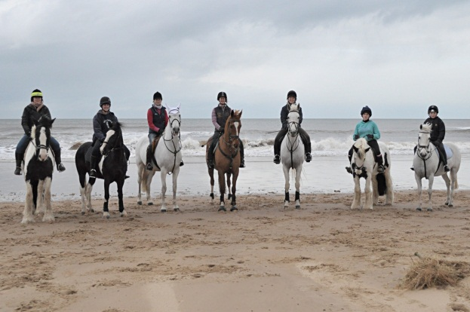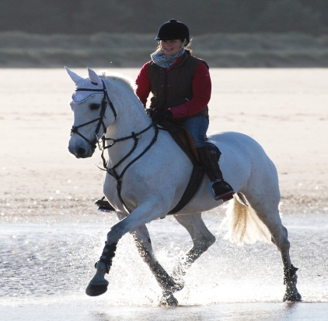
Gordon Crane

If anyone has any photos or info they would like included in the next Newsletter please forward to: rosemary.stevens632@btinternet.com

